Download and use the following files of functions and data:
https://www.msu.edu/~bowmanm/231/Lab11.zip
Functions are provided that will read data from a file into a Binary Search Tree structure and display it in ascending order. Compile the program and verify that it works with the data file provided.
Part 1
Remove the /* */ comments in main() for PART 1. Do not change other code in Main.cpp, Node.h, or Node.cpp. Using the file Node Answers.cpp, implement the node::lmr() function that will display the nodes in the tree. Run the program and save your output.
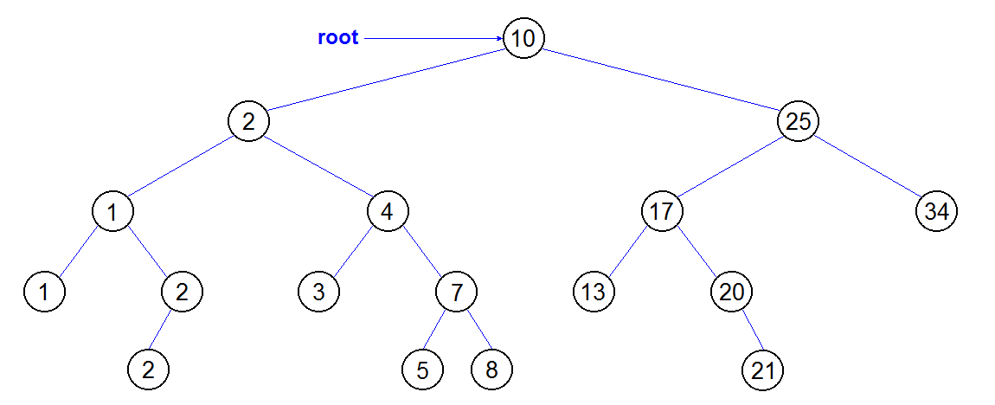
Sample Output
Enter file name: Lab11.txt

Entire Tree
1 1 2 2 2 3 4 5 7 8 10 13 17 20 21 25 34
Part 2
Remove the /* */ comments in main() for PART 2. Do not change other code in Main.cpp, Node.h, or Node.cpp. Using the file Node Answers.cpp, implement the node::leaves() function that will display only the leaf nodes (nodes without children) in the tree. Run the program and save your output.
Sample Output
Enter file name: Lab11.txt

Entire Tree
1 1 2 2 2 3 4 5 7 8 10 13 17 20 21 25 34

Leaves
1 2 3 5 8 13 21 34
Part 3
Remove the /* */ comments in main() for PART 3. Do not change other code in Main.cpp, Node.h, or Node.cpp. Using the file Node Answers.cpp, implement the node::leaves(int) function that will display the leaf nodes and their depth in the tree. Run the program and save your output.
Sample Output
Enter file name: Lab11.txt

Entire Tree
1 1 2 2 2 3 4 5 7 8 10 13 17 20 21 25 34

Leaves
1 2 3 5 8 13 21 34

Leaf Depth
----- -----
1 3
2 4
3 3
5 4
8 4
13 3
21 4
34 2

What to hand in
Hand in a copy of your code for Node Answers.cpp. Cut and paste your outputs for each part into a MS-Word document and print it. Do not turn in screen shots – it wastes ink! Your code will be graded on its functionality, appearance, and comments.

Output:
Enter file name: Lab11.txt

Entire Tree
1 1 2 2 2 3 4 5 7 8 10 13 17 20 21 25 34

Leaves
1 2 3 5 8 13 21 34

Leaf Depth
----- -----
1 3
2 4
3 3
5 4
8 4
13 3
21 4
34 2

NodeAnswers.cpp

/************************************
* Node Answers.cpp
* Updated by Alex Phelps
************************************/

#include <iostream>
#include <iomanip>
using namespace std;

#include "Node.h"

//Prints left child, then self, then right child (recursively)
void node::lmr()
{
if (left != NULL) left->lmr(); // left
cout << val << ' '; // print self
if (right != NULL) right->lmr(); // right
}

//Prints only leaves
void node::leaves()
{
bool leaf = true;

if (left != NULL)
{
leaf = false;
left->leaves(); //recurse left
}

if (right != NULL)
{
leaf = false;
right->leaves(); //recurse right
}

if (leaf) cout << val << ' '; //if this is a leaf, print
}

//Prints leaves and their depth
void node::leaves(int depth)
{
bool leaf = true;

if (left != NULL)
{
leaf = false;
left->leaves(depth + 1); //recurse left, add to depth
}

if (right != NULL)
{
leaf = false;
right->leaves(depth + 1); //recurse right, add to depth
}

if (leaf) cout << setw(5) << val << " " << setw(5) << depth << endl; //if this is a leaf, print
}

